Guidelines for Preparation of Full Paper (Times New Roman, 12 Point, Bold)
(1 empty line)
First Author¹* (Author (Presenter): Point Size10, Bold), Second Author² (Co-Author(s): Point Size10, Bold)
(1 empty line)
¹Department of Engineering Mechanics, Dalian University of Technology, 116023, Dalian, China
* Corresponding author: XXXX@dlut.edu.cn
(Affiliation: Point Size 10, italic, including city, country and email address)
²National Engineering Research Center for Advanced Polymer Processing Technology, Zhengzhou University, 450002, Zhengzhou, China
(1 empty line)
Abstract
This file provides the guidelines for preparation of a full paper for the Asian Congress of Structural and Multidisciplinary Optimization 2024 (ACSMO 2024). Please follow the instructions detailed below.
(1 empty line)
Keywords: Structural optimization, shape optimization, topology optimization (Three to five keywords should be typed here in italic, separated by commas.)
(1 empty line)
1. Introduction
Full papers of ACSMO 2024 will be published in the electronic proceedings, distributed at the congress site. A full paper should be no less than two pages length and not over ten pages, and should be converted to a PDF file by the author(s)' responsibility. Submission of a full paper should be completed through the ACSMO 2024 web page (https://acsmo2024.cn/) no later than March 31, 2024.
The manuscript must be typed on A4 sheets (297 mm in height and 210 mm in width). The left and right margins should be 20 mm, and the top and bottom margins should be 35 mm and 30 mm, respectively. Accordingly, the typing area of each page is 232x170 mm (9.13x6.69 inch).

2. Typing instruction
The text should be typed in black color. The font Times New Roman or (if not available) a similar one should be used. Use of 10-point font and single line space for the main text is mandatory. Type the title of the paper on the top of the first page. Allow one blank line between the title of the paper and the name(s) of author(s), one blank line between the name(s) of author(s) and the affiliation(s) of author(s), and one blank line below the affiliation(s) of author(s). Similarly, allow one blank line between the abstract and the list of key words, and one blank line below the list of keywords. Do not put a blank line between two successive paragraphs of the body text.

2.1. Title
The title of the paper should be typed in upper and lower cases with 12-point boldface. The title should be centered.

2.2. Name(s) of author(s)
Type the name(s) of author(s) with 11-point boldface, in the order of first name (forename) and last name (surname). The name(s) of author(s) should be centered.

2.3. Affiliation(s)
The affiliation(s) of the author(s) (including city and country, as well as e-mail address of the corresponding author) should be typed below the list of authors. The affiliation(s) should be centered and typed with 11-point plane typeface.

2.4. Abstract
The abstract should not include references and displayed equations. Allow one blank line between the affiliation(s) of author(s) and the abstract.

2.5. Keywords
Three to five keywords should be provided. The keywords should be typed in italic, and be separated by commas. There should be one blank line below the keywords.

2.6. Sections and section headings
The paper should be divided into sections numbered as 1, 2, 3, etc. Subsections should be numbered as 1.1, 1.2, 1.3, etc. Section headings should be typed with 10-point boldface, and start with an upper case letter, followed by lower case letters. Subsection headings should be typed with 10-point plane typeface, and start with an upper case letter, followed by lower case letters. Allow one blank line above each heading.

2.7. Equations
All equations must be clearly typed and consecutively numbered. All equations should be centered. Displayed equations should be numbered simply as (1), (2), (3), etc; e.g.,
$H=2\left(F(X_{1})−F(X_{2})−\sum_{i=1}^{n}{\frac{∂F(X_{2})}{∂x_{i}}\frac{(x_{i,2}−a_{i})^{1−m_{i}}}{m_{i}}[(x_{i,1}−a_{i})^{m_{i}}−(x_{i,2}−a_{i})^{m_{i}}]}\right)$ (1)
The numbers should appear at the extreme right of the line. Refer to equations in the text as Eq. (1), Eq. (2), Eq. (3), etc.

2.8. Tables and figures
Tables and figures, respectively, should be consecutively numbered. Place a table title above every table, and a figure caption below every figure. Allow one blank line between a table and its title, and one blank line between a figure and its caption. Allow one blank line between a table and body text, and one blank line between a figure and body text. Tables should meet the form of three-line table. Refer to tables and figures in the main text as Table 1 and Fig. 1, respectively.

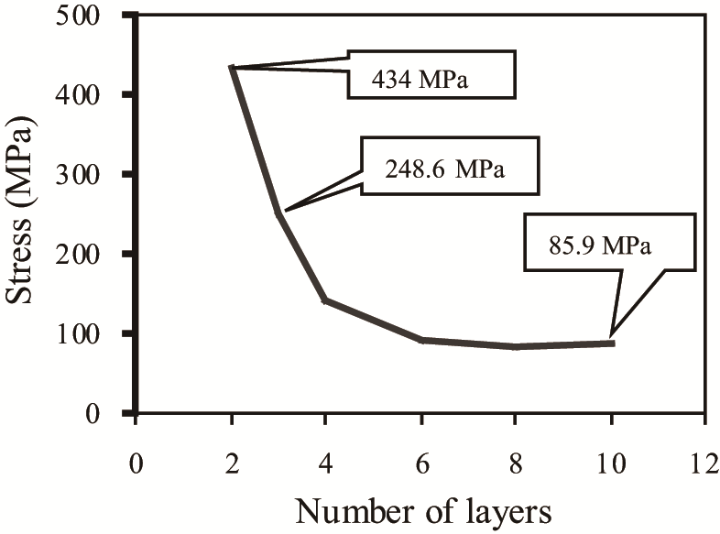
Figure 1. Circumferential stress.

Table 1. Material properties.

T (mm) | $$α$$ | Fraction | E₁ (MPa) | E₂ (MPa) | G₁₂ (MPa)
10.0 | −0.3038 | 0.1458 | 7087.03 | 103.81 | 41.30
20.0 | −0.9977 | 0.2848 | 14462.00 | 645.08 | 275.96
30.0 | −2.4270 | 0.2848 | 22456.00 | 1905.70 | 934.38
40.0 | −5.1850 | 0.5696 | 31842.00 | 3955.00 | 2306.10

2.9. References
References should be listed at the end of the paper and consecutively numbered. Refer to references in the text with reference number in brackets as [1], [2], [3], etc. Style the reference list in accordance with the examples at the end of this file. The standard abbreviations of journal titles can be used.

Acknowledgments
Acknowledgments of people, grants, funds, etc. should be placed before the list of references, as an unnumbered separate section.

References
[1] Bendsoe, M. P., & Sigmund, O. (2003). Topology Optimization: Theory, Methods, and Applications. Springer Science & Business Media.
[2] Cheng, G. D., & Guo, X. (1997). ε-relaxed approach in structural topology optimization. Structural Optimization, 13, 258-266.

